1. **Cannot Edit a Record in Net Requirements (RegTrans). An update conflict occurred due to another user process deleting the record or changing one or more fields in the record.**They are trying to return the part -Select Sale order then the line - Arrival journal - they then select Registration the error appears. To fix this they need to cancel the arrival journal

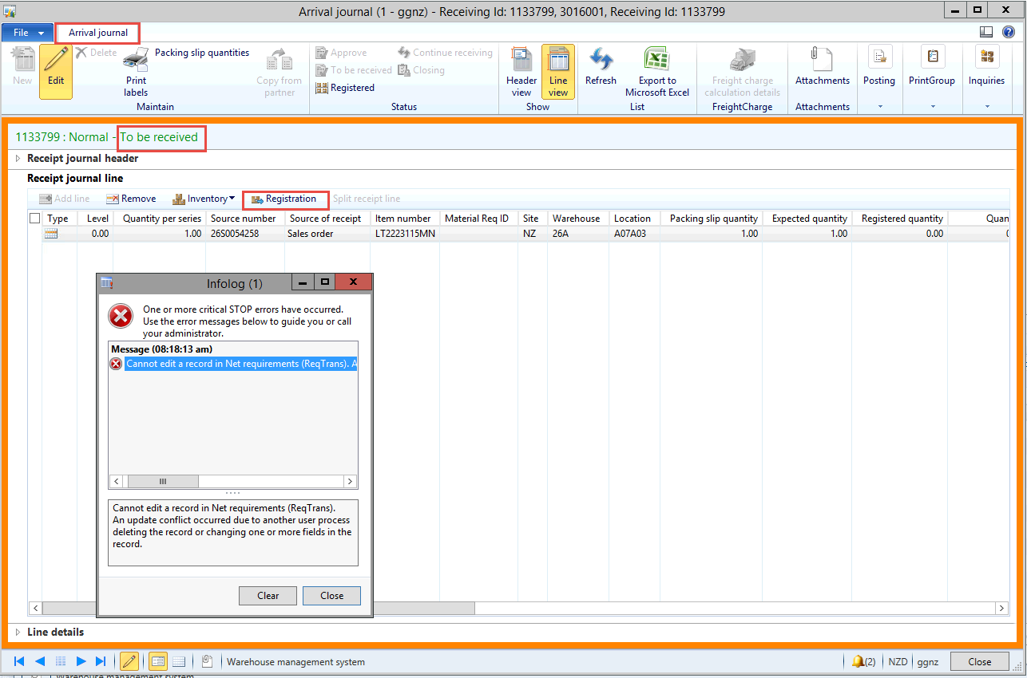

Select Registrered - then OK

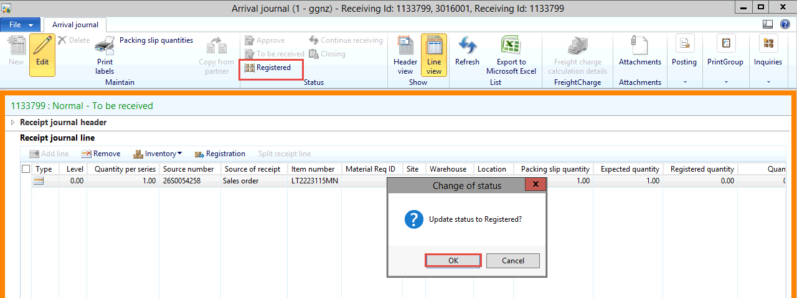

Select Closing and OK

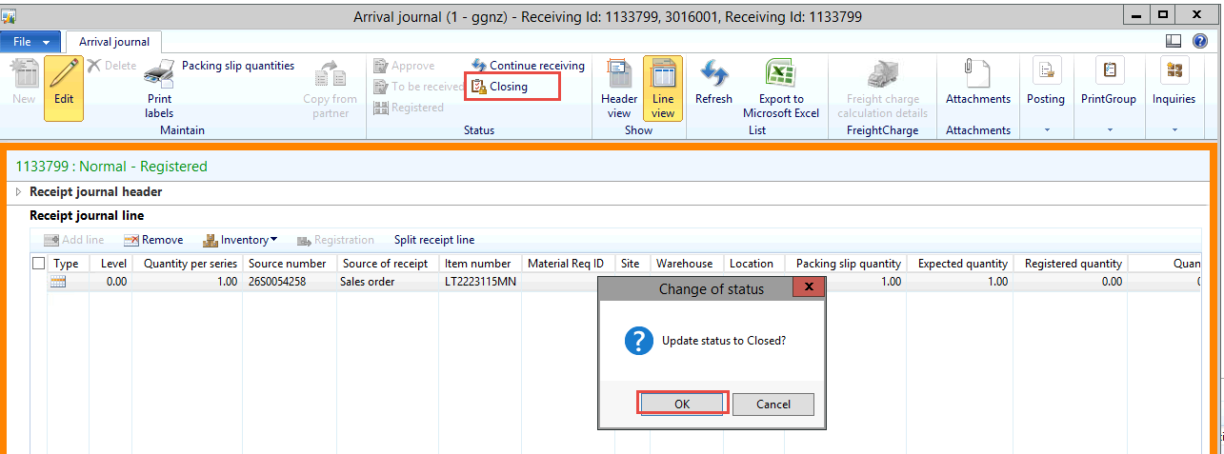

Close the journal - by killing this we are able to do the work around.

The work around is select the line on the sale order - Update Line - registration

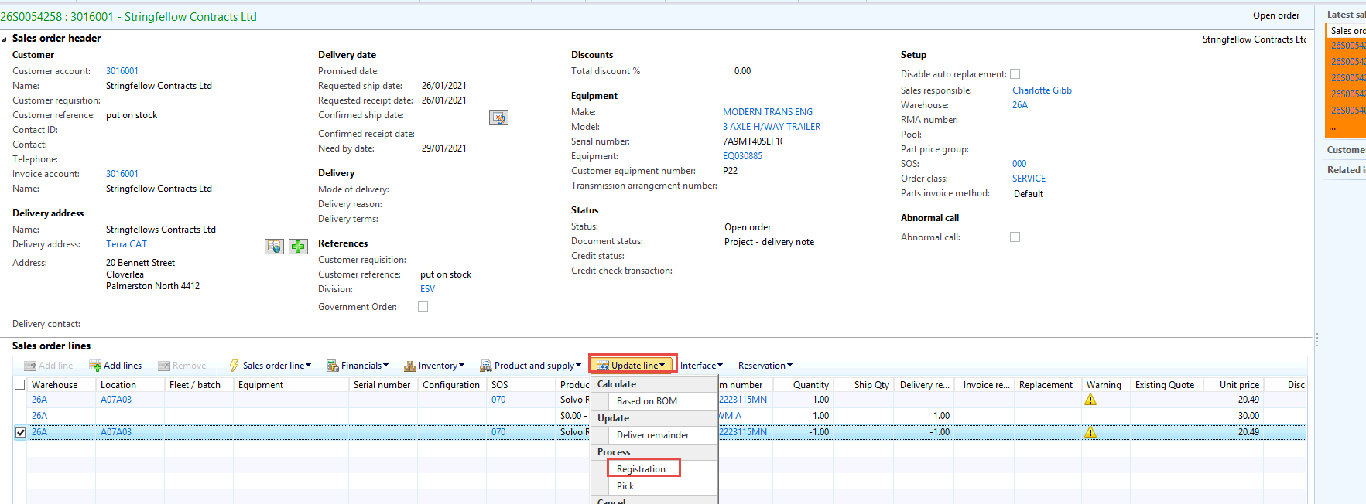

They select Auto-create - and before they select post all they can change the location. If they had multiple lines they would need to do this step for each line.

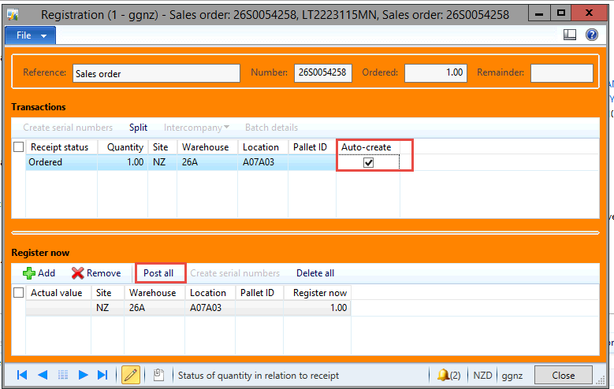

They now go to delivery Note

